
Further details are available on Facebook and the club website www.yorksclassictrials.co.uk
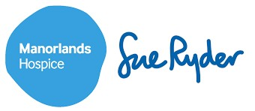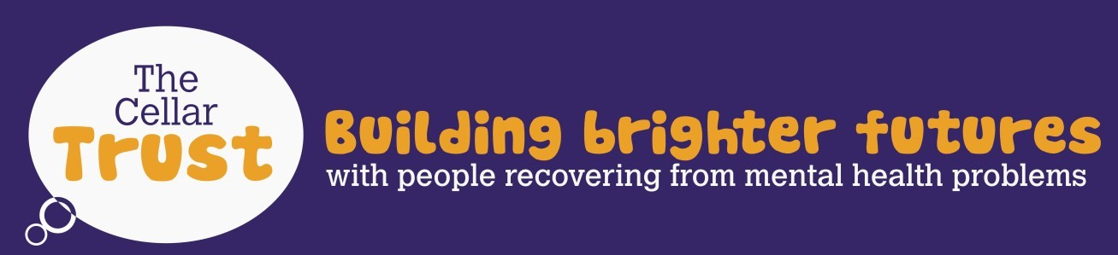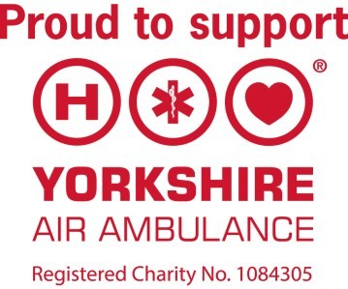

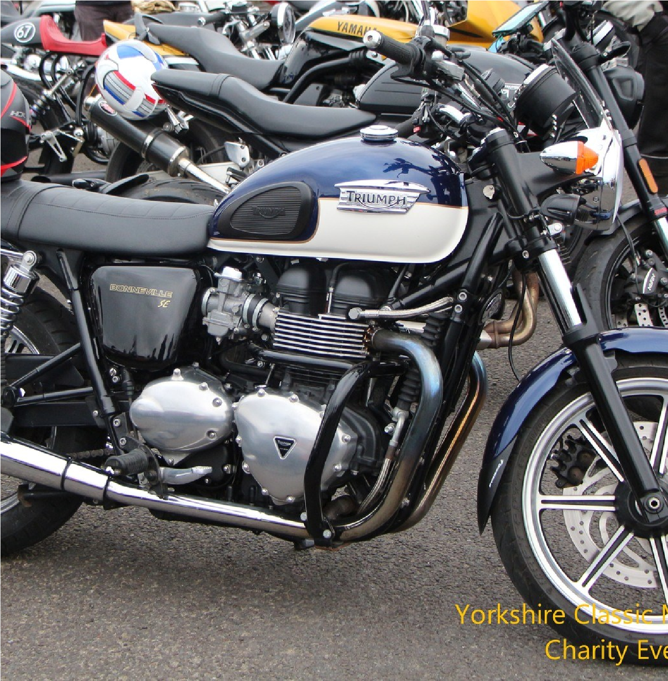

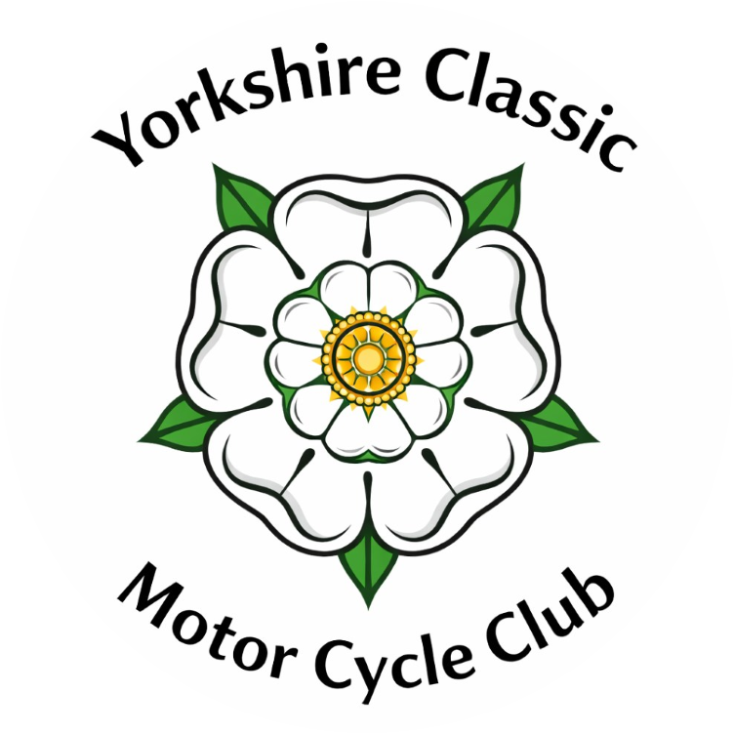
The Country Manor, Bingley Road, Lees Moor, Keighley BD21 5QE

£3
Donation

Please have cash ready on the gate

Cash only - No cards
All money raised goes to charity

Classic Bike Classes:
- Girder Fork Rigid
- British up to 1990
- Foreign up to 1990
- Military up to 1970
- Reproduction (Enfield’s, Bonneville, etc.)
- Customised (Harley, etc.)
- British Competition up to 1970
- Scooters, Mopeds up to 1990
Keighley
Food available during the show
Table bookings can be made for meals in the restaurant

Classic Bike Show
Wednesday 22nd July 2026
Exhibitors from 5pm

Spectators from 6pm

